1. Heap-organized tables

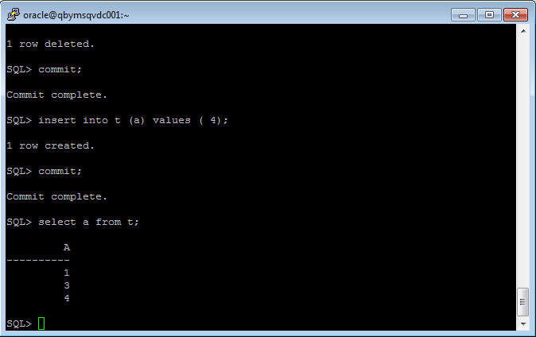

Capture 1 – Task results

Heap tables are unsorted data which is stored in blocks. When some row in block are deleted, new row **can** hold its place in block (but now always!! Its depend on different factors like pctfree and pctused and so on).

2.

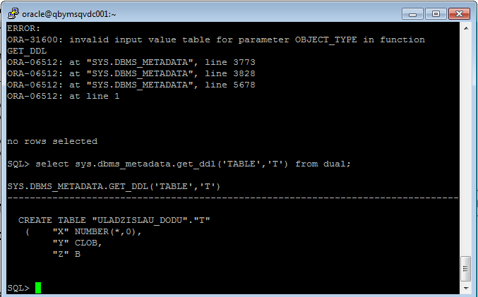

Capture 1 – Task results

For tables and indexes Oracle creates a segment (logical memory level)

3.

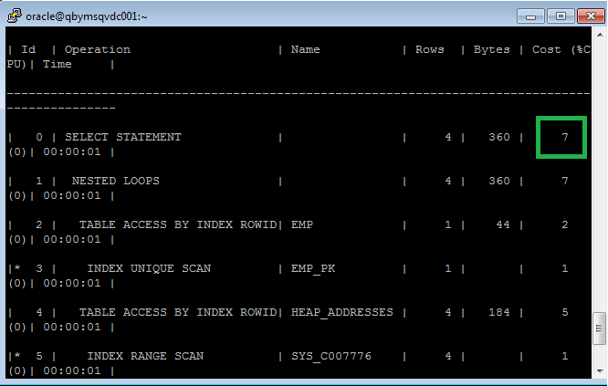

Capture 1 – First query’s cost

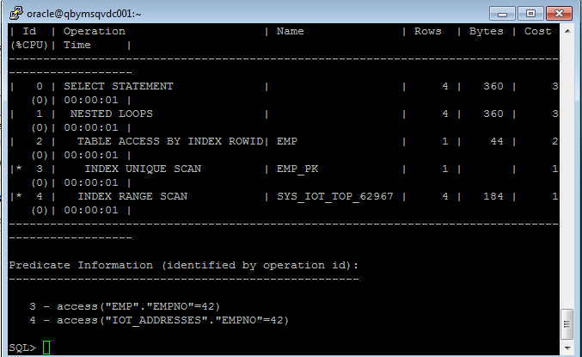

Capture 2 – Second query’s cost

Explanation: Second query’s cost less than first query because second table was created as index organized table. That means that all columns from second table store in index’s leafs. That is why in explain plan we don’t see any table scan.

4.

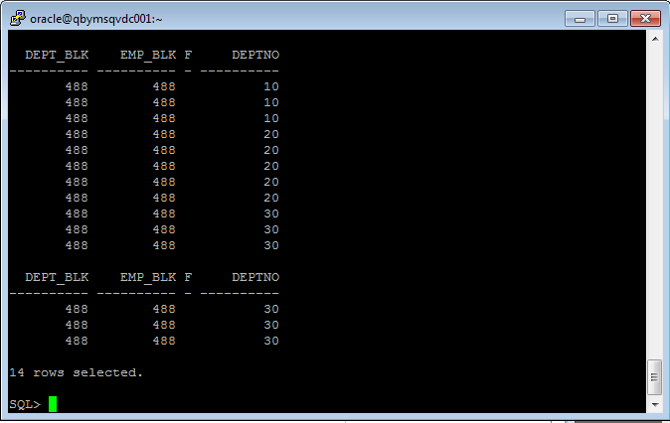

Capture 1 – Task results

Explanation: When we create index clustered tables, we create an one segment (one or more blocks) for common in case our tables index, which references (by rowed I guess ) to tables (second segment). Reference is supplied by system processes

Advantages:

1. Store pre-joined data;

Very useful for queries with join, because one segment consists all data what we need(table segment).

5.

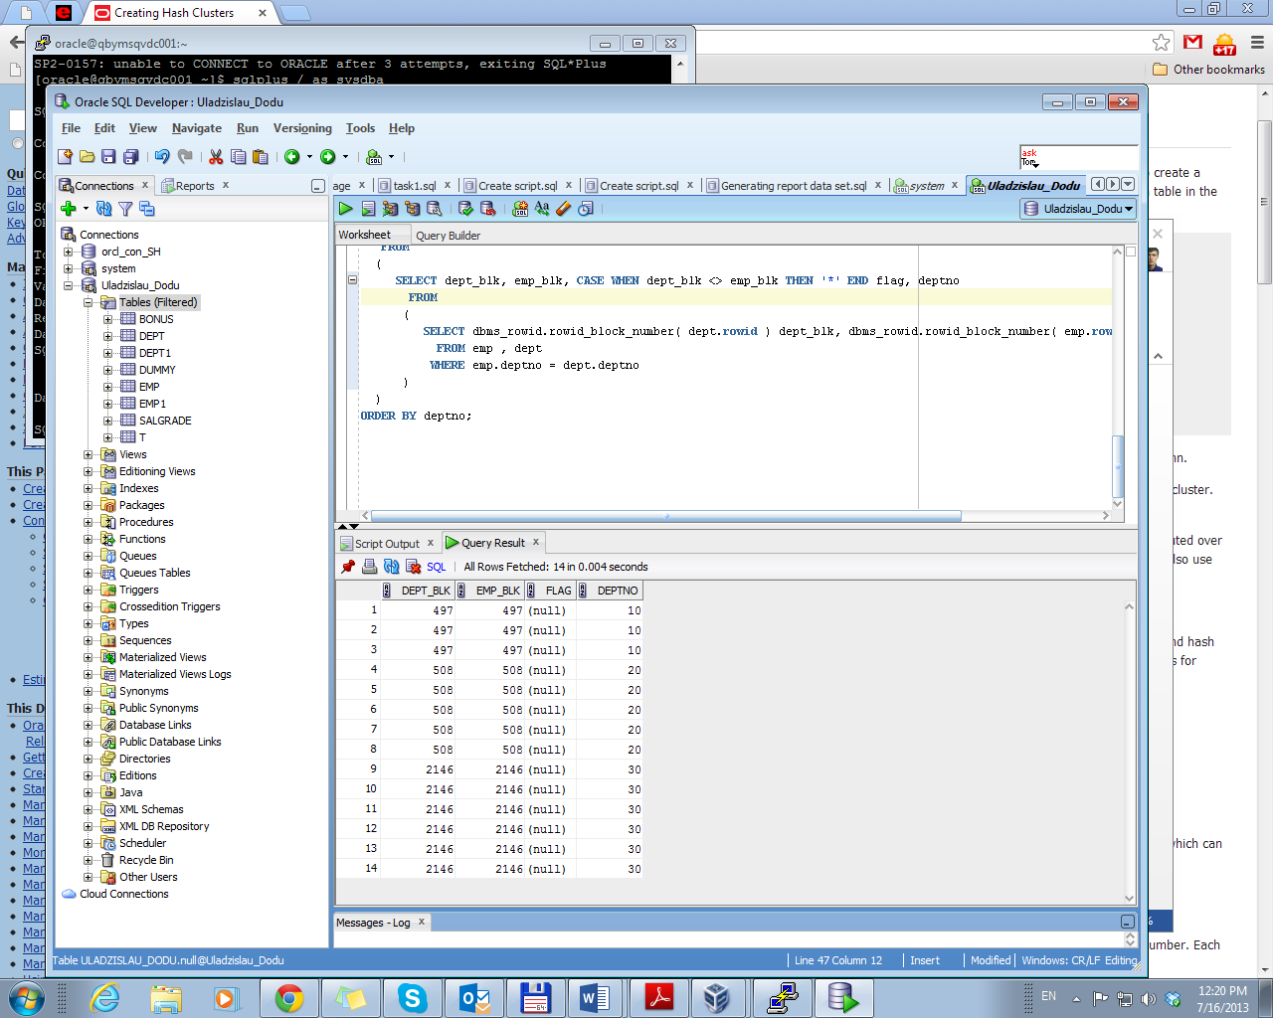

Oracle distribute data according hash key values.

Engine of that type of tables are the similar with Index Clustered Table except that it doesn’t create index. Oracle physically stores the rows of a table in a hash cluster and retrieves them according to the results of a **hash function**. It uses hash function to create a hash key values (as index in Index Clustered Tables).

Advantages:

* Improve data retrieval
* I guess it has to improve hash join with other tables